

Seminar the 21th of March, from 09.00-10.00 am CET at zoom
Exchange & cooperation between Italian biodistricts and Tunisian bioterritoires. Good practices, lessons learnt and prospects
Speaker: Dr. Patrizia Pugliese, Mediterranean Agronomic Institute of Bari, Italy
Agro-economist, senior researcher and development officer at CIHEAM Bari, Ph.D in Policies for Sustainable Development, MSc in Rural Resources and Countryside Management. She has twenty-five-year experience in research, training and development cooperation work on rural development, sustainable and organic agriculture in EU and developing countries, with deeper expertise in the Mediterranean region and focus on rural economy diversification, sustainable and inclusive value chain development, place-based and eco-region approaches to territorial development. Current fields of interest and work also include rural women’s empowerment and meaningful participation to agri-food value chains and rural economy, agroecological transitions, organic districts and sustainable organic food systems. Author of various scientific contributions, with participation to different EU-funded research projects. Member of the CIHEAM Bari Secretariat of the Mediterranean Organic Agriculture Network (MOAN). Focal point for CIHEAM Bari Institute of CIHEAM corporate Working Group on Gender.

Join Zoom Meeting
Susanne Gjedsted Bügel is inviting you to a scheduled Zoom meeting.
Join Zoom Meeting
https://ucph-ku.zoom.us/j/69266880595?pwd=0lMkPasb7pqJpRV2dMSQ5WtdzTUoba.1
Meeting ID: 692 6688 0595
Passcode: 687562
The workshop is free of charge
Program:
09.00-09.05 am welcome by FQH Carola Strassner
09.05-09.35 am
Exchange & cooperation between Italian biodistricts and Tunisian bioterritoires. Good practices, lessons learnt and prospects
By Patrizia Pugliese
09.35-09.55 am discussions in plenum or breakout-rooms (dependent on the numbers of attendants)
09.55-10.00 am wrap-up, presentation of next workshop and goodbye

Abstract
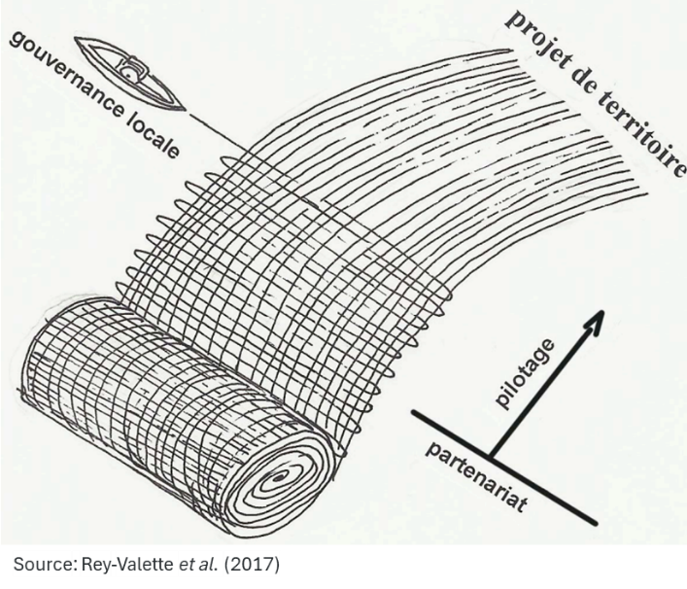  The setting up of a ‘biodistrict’ (or ‘eco-region’, bioregiões, ökomodellregionen, bioterritoires, etc.) in a territory is a medium- and long-term | process of co-construction involving important individual and collective choices.  It requires an inclusive and careful mapping of local values, resources, and needs to be able to encourage stakeholders’ pro-active approach and effectively unlock the territory’s potential for agroecological transition and sustainable development.  A life journey that is worth taking in good company …  A recently ended project funded by the Italian cooperation in Tunisia provided the opportunity to support the emergence five of ‘bioterritoires’ and to frame interesting exchanges with four Italian biodistricts.  I’ll be happy to share with you more about this inspiring experience on 21 March.

